E-Conference Paper Formatting Instructions: Use 12-Point Bold Times Roman Font in the Title

First-name Last-Name and First-name Last-Name

ABSTRACT
Your abstract should be limited to 150 words; it must never exceed the first page or contain artwork or references. The abstract should present a concise statement of the scope, principal findings, and conclusions of the paper.

Paper FORMAT

Author contact information
A sample of author contact information is shown above in this document. The following information may be provided for all authors of the paper: author’s full name; Society membership grade; academic degrees or honorifics; current employment affiliation; postal and electronic mailing addresses; phone and fax numbers.

Style
The paper must be written in the best possible technical and grammatical English. Titles should be concise and should describe the content of the paper. If you have a long title, please consider a Title: Subtitle format, as the title of this document.

Length
The maximum paper length (including all text, figures, references, and appendices) is 20 pages.

Point size and font
Only one point size (12 point) and one font (Times New Roman including Italics, bold, and bold italics) can be used in the paper.

Margin
The text area must contain all elements of the paper that will be reproduced (text, figures, tables, captions). Imagine a “box” whose width does not exceed 5.75" (14.5 cm) and depth does not exceed 9" (22.5 cm). Short pages are unsightly and waste space; try to fill the imaginary box on each page. For the Standard American Letter size page, leave at least 2.54 cm (1") top and bottom margins and 3.49 cm (1.375") in the left and right margins (Table 1 summarizes the margin settings for the Letter and A4 size pages.)

Table 1. Margin Settings for Standard American Letter and International A4 Size
Margins | Letter (8.5" x 11") | A4 (21cm × 29.7 cm)
Top | 1.00" | 3.50 cm
Bottom | 1.00" | 3.50 cm
Left | 1.375" | 3.25 cm
Right | 1.375" | 3.25 cm

Layout
All text must be single-spaced. Indent the first line of each paragraph by 1.27 cm (0.5"). Text should be left and right justified across whole page width.
Use 12-Point Bold Times Roman Font in the Title. Center the paper title and add additional 1.27 cm (0.5") before spacing. Leave one blank line between the paper title and author names, one blank line between author names and author affiliations, and one blank line between author affiliations and abstract.
Leave one blank line above headings. Use bold All Capitals for section titles, Bold Initial Capitals for subsection titles, and Italics Initial Capitals for sub-subsection titles.
Leave at least one blank line both above and below equations, illustrations and tables (including the caption), unless they are placed at the top or bottom of the page.
Page design should be consistent throughout the paper.

Figures and tables
All graphics (photos, line art, and tables) must fit within the above margin settings. All graphics should be understandable when printed in black and white. Do not use only color as a distinguishing feature. Use symbols or patterns on line and bar graphs to identify lines and columns. Landscape orientation is acceptable.
Illustrations should be numbered consecutively as they are presented (Figure 1, Figure 2, etc., and Table 1, Table 2, etc.). Each figure should be mentioned or called out before it appears. More than one figure may appear on a page.

Captions and legends
A descriptive caption, including figure number, should be placed directly above the illustration (see Figure 1). A descriptive legend, including table number, should be placed immediately above the table (see Table 1).

Figure 1. Sample Figure
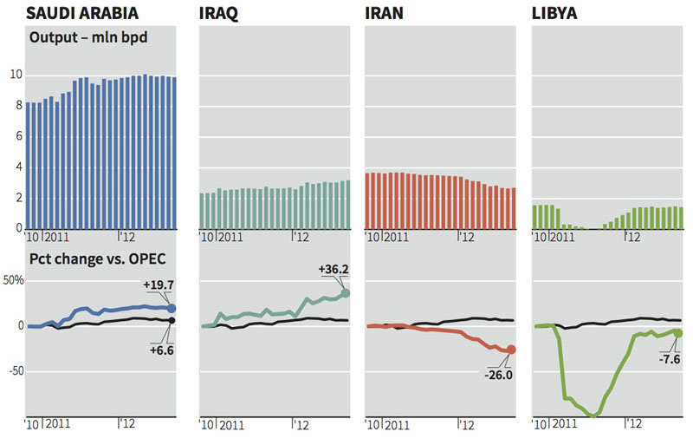

Mathematics
All mathematics must be embedded in the text using an equation editor (i.e. Math type). Equations need to be numbered only if they are referred to more than once.

$V(d)=\left\{v|v=\sum{x^{w}},{Δx}^{w}=E^{w}d_{w},x^{w}≥0,∀w∈W\right\}$ (1)

System of units
Authors must use the International System of Units (SI), and units acceptable in SI. Alternatively, dual units can be provided with SI given first and corresponding English Imperial units given in parentheses. For more information about SI units, go to the U.S. Metric Association (USMA), Inc. site (http://lamar.colostate.edu/~hillger/) or the National Institute of Standards and Technology (NIST) site (http://physics.nist.gov/cuu/Units/index.html).

PERMISSIONS
If a figure, photograph, or table has been published previously, the author must obtain written approval from the original publisher.

APPROVALS
It is the author’s responsibility to obtain all necessary approvals from the author’s employer prior to submission of the paper. Once a paper has been uploaded, reviewed by the author, and officially submitted, it is not possible to edit the document.

COPYRIGHT TRANSFER AND PERMISSIONS VERIFICATION
No paper can be included in publication unless the author has agreed to the terms of Copyright Transfer Agreement form and the Permissions Verification form.

CONCLUSION
With thanks for your efforts, we look forward to providing a record of this conference that will be useful and have experimental evidence about sanctioned countries.

REFERENCES
All references should appear together at the end of the paper. References are listed alphabetically by last name of the first author. When two or more references by the same author are listed, year of publication is taken into account, and the earliest work is listed first. Wherever reference is made in the text to an author’s work, the author’s name and year of publication should appear in parentheses. Superscripts shall NOT be used to denote references, as these numbers often appear too small to be read easily. All listed references must be cited in text.
Below are examples of referenced works from published books, journals and hard-copy documents. For other instructions, please refer to http://www.asce.org/Content.aspx?id=29605.

Chang, E. C. P. (1996). “Guidelines for actuated controllers in coordinated systems.” Transportation Research Record, 1554, Transportation Research Board, Washington, D.C., 61–73.
Dahlgren, J. (2002). “High-occupancy/toll lanes: Where should they be implemented.” Transportation Research Part A, 36, 239–255.
Halvorson, R., Nookala, M., and Buckeye, K. R. (2006). “High occupancy toll lane innovations: I-394 MnPASS.” Proceedings of 85th Annual Meeting of the Transportation Research Board (Compendium of Papers, CD-ROM), No. 06-1265.
Minnesota Dept. of Transportation. (2006). “I-394 MnPASS technical evaluation final report.” <http://www.mnpass.org/pdfs/394mnpass_tech_eval.pdf> (May 24, 2008)
Pigou, A. C. (1920). Wealth and welfare, Macmillan, London.
Quadstone Limited. (2003). Quadstone paramics V4.2 user’s guide, Edinburgh, Scotland, U.K.
Yin, Y. and Lawphongpanich, S. (2007). “A robust approach to continuous network designs with demand uncertainty.” Proceedings of 17th International Symposium on Transportation and Traffic Theory, R. E. Allsop, M. G. H. Bell, and B. G. Heydecker, eds., Elsevier, New York, 111–126.

PHD of economics, Department of Environmental economic, Research State University, P.O. Box 6488, City, ST 99999-1111; PH (777) 911-1234; FAX (777) 911-1235; email: imauthor@ytsu.edu
researcher, Hop Company; email: co.author@ytus.com

